GOODS RETURN FORM
SOLVER Sp. z o. o.
Shipping address return :
SOLVER Sp. z o. o. - Warehouse
ul. WENUS 7980-299 Gdańsk
tel. 58 511-04-31
POLAND

Conditions return goods :
- Return in full undamaged packaging.
- Additionally, a fee for repacking the goods will be added in the amount of PLN 20 net/pack.
- Return shipping charges remain the responsibility of the customer.
- Used, dirty and unfit for resale goods will be disposed of.
- Please place the completed form in the rebate on the outside of the pallet/box.
- Please fill out legibly and send to Solver Sp. z o. o.
- The cost of transport to Solver is covered by the returnee.
- Detailed return conditions can be found in the General Terms and Conditions
Data to fill in By buyer :
Date of form completion:
Buyer name:
Tax identification number:
Order delivery address:
Delivery note number WZ:
Delivery date:
Invoice number:

Report reception return ( completed by Solver Sp. z o. o. ):
Date of return acceptance:

Quality of returned products: | 1. Quality equivalent to new  2. Good functional quality with signs of use  3. Disposal - not suitable for resale
Number of repacks:
Number of new labels:
Number of rejections, reason and photos for documentation:
Legible signature of the person accepting the return:

Product Group | Image | Code | Short name | Name | Purchased quantity | Returned quantity
Paver supports | 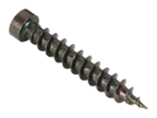  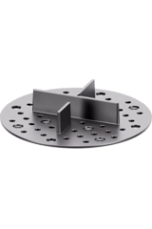 | 101.010111 | PAD-002B-(350) | 2 mm tile cross spacer for dry laying on sand, grass, gravel with built in 3 mm gap spacers - black / 350 pcs (50x7) Alliq
Paver supports | 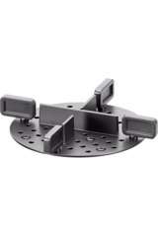 | 101.010211 | PAD-002B-L5-(300) | 2 mm tile cross spacer for dry laying on sand, grass, gravel with built in 3 mm and individual gap spacers 5 mm - black / 300 pcs
Paver supports | 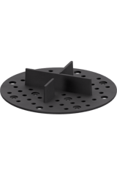 | 101.010311 | PAD-002R-(350) | 2 mm tile cross spacer for dry laying on sand, grass, gravel with built in 3 mm gap spacers - rubber / 350 pcs
Paver supports | 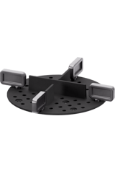 | 101.010411 | PAD-002R-L5-(300) | 2 mm tile cross spacer for dry laying on sand, grass, gravel with built in 3 mm and individual gap spacers 5 mm - rubber / 300 pcs
Paver supports | 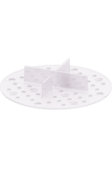 | 101.010511 | PAD-002T-(350) | 2 mm tile cross spacer for dry laying on sand, grass, gravel with built in 3 mm gap spacers - transparent / 350 pcs
Paver supports | 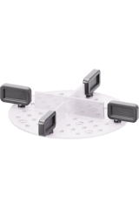 | 101.010611 | PAD-002T-L5-(300) | 2 mm tile cross spacer for dry laying on sand, grass, gravel with built in 3 mm and individual gap spacers 5 mm - transparent / 300 pcs
Paver supports | 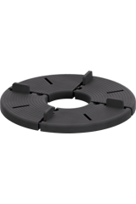 | 101.020111 | PAD-008-(200) | 8 mm fixed height pavers support pad with built in 3 mm gap spacers - rubber / 200 pcs
Paver supports | 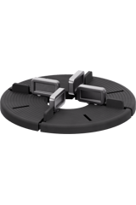 | 101.020211 | PAD-008-L5-(200) | 8 mm fixed height pavers support pad with built in 3 mm and individual gap spacers 5 mm - rubber / 200 pcs
Paver supports | 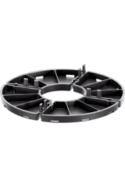 | 101.030111 | PAD-010-L3-(400) | 10 mm fixed height pavers support pad with built in 3 mm gap spacers / 400 pcs
Paver supports | 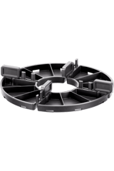 | 101.030211 | PAD-010-L5-(400) | 10 mm fixed height pavers support pad with built in 3 mm and individual gap spacers 5 mm / 400 pcs
Paver supports | 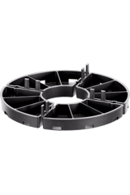 | 101.040111 | PAD-015-L3-(300) | 15 mm fixed height pavers support pad with built in 3 mm gap spacers / 300 pcs
Paver supports | 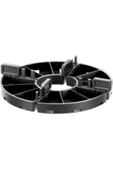 | 101.040211 | PAD-015-L5-(300) | 15 mm fixed height pavers support pad with built in 3 mm and individual gap spacers 5 mm / 300 pcs
Paver supports | 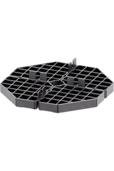 | 101.050111 | PAD-016-L3-(90) | 16 mm fixed height pavers support pad with built in 3 mm gap spacers / 90 pcs
Paver supports | 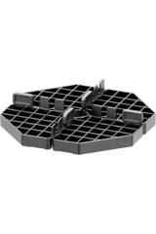 | 101.050211 | PAD-016-L5-(90) | 16 mm fixed height pavers support pad with built in 3 mm and individual gap spacers 5 mm / 90 pcs
Standard | 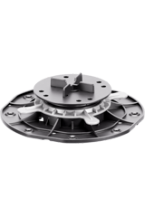 | 102.010411 | STA-030-045-K3-(100) | Adjustable pedestal STANDARD 30-45 mm for outdoor raised flooring for tiles with K3 / 100 pcs
Standard | 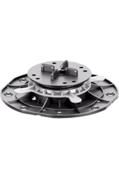 | 102.010511 | STA-030-045-K5-(100) | Adjustable pedestal STANDARD 30-45 mm for outdoor raised flooring for tiles with K5 / 100 pcs
Standard | 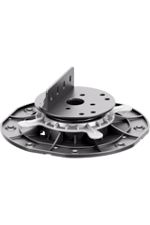 | 102.010611 | STA-030-045-AD-(100) | Adjustable pedestal STANDARD 30-45 mm for outdoor raised flooring for decking with AD / 100 pcs
Standard | 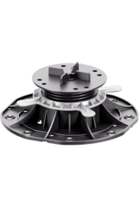 | 102.020411 | STA-045-070-K3-(70) | Adjustable pedestal STANDARD 45-70 mm for outdoor raised flooring for tiles with K3 / 70 pcs
Standard | 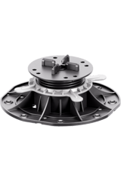 | 102.020511 | STA-045-070-K5-(70) | Adjustable pedestal STANDARD 45-70 mm for outdoor raised flooring for tiles with K5 / 70 pcs
Standard | 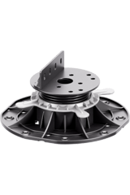 | 102.020611 | STA-045-070-AD-(70) | Adjustable pedestal STANDARD 45-70 mm for outdoor raised flooring for decking with AD / 70 pcs
Standard | 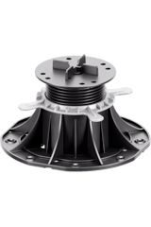 | 102.030411 | STA-070-120-K3-(50) | Adjustable pedestal STANDARD 70-120 mm for outdoor raised flooring for tiles with K3 / 50 pcs
Standard | 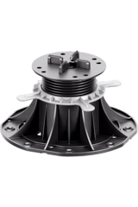 | 102.030511 | STA-070-120-K5-(50) | Adjustable pedestal STANDARD 70-120 mm for outdoor raised flooring for tiles with K5 / 50 pcs
Standard | 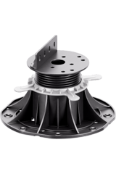 | 102.030611 | STA-070-120-AD-(50) | Adjustable pedestal STANDARD 70-120 mm for outdoor raised flooring for decking with AD / 50 pcs
Standard | 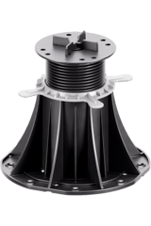 | 102.040411 | STA-120-220-K3-(36) | Adjustable pedestal STANDARD 120-220 mm for outdoor raised flooring for tiles with K3 / 36 pcs
Standard | 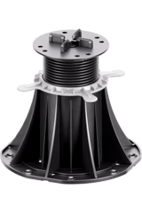 | 102.040511 | STA-120-220-K5-(36) | Adjustable pedestal STANDARD 120-220 mm for outdoor raised flooring for tiles with K5 / 36 pcs
Standard | 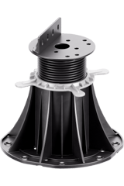 | 102.040611 | STA-120-220-AD-(36) | Adjustable pedestal STANDARD 70-120 mm for outdoor raised flooring for decking with AD / 36 pcs
Standard | 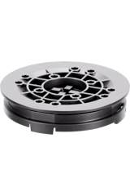 | 102.060111 | STA-LE100-(250) | Self leveling head for STANDARD with maximum slope compensation 7% - height 16 mm / 250 pcs
Standard | 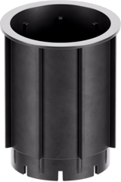 | 102.070111 | STA-DS100-(100) | Height coupler for STANDARD - height 100 mm / 100 pcs
Clever Level | 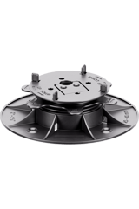 | 105.010111 | CLE-025-040-L3-AD-(200) | Adjustable pedestal Clever Level 25-40 mm for outdoor raised flooring for tiles and decking / 200 pcs
Clever Level | 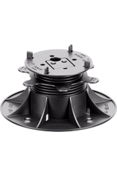 | 105.020111 | CLE-040-080-L3-AD-(120) | Adjustable pedestal Clever Level 40-80 mm for outdoor raised flooring for tiles and decking / 120 pcs
Clever Level | 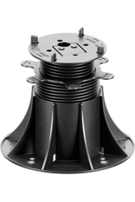 | 105.030111 | CLE-080-200-L3-AD-(50) | Adjustable pedestal Clever Level 80-200 mm for outdoor raised flooring for tiles and decking / 50 pcs
Spiral | 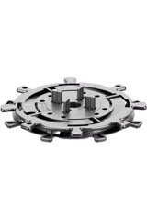 | 103.010211 | SPI-010-017-D3-(125) | Adjustable pedestal SPIRAL 10-17 mm for outdoor raised flooring for tiles with D3 / 125 pcs
Spiral | 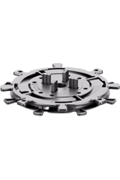 | 103.010311 | SPI-010-017-D5-(125) | Adjustable pedestal SPIRAL 10-17 mm for outdoor raised flooring for tiles with D5 / 125 pcs
Spiral | 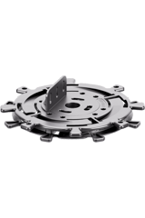 | 103.010411 | SPI-010-017-DAD-(125) | Adjustable pedestal SPIRAL 10-17 mm for outdoor raised flooring for decking with DAD / 125 pcs
Spiral | 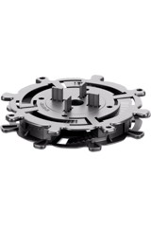 | 103.020211 | SPI-017-030-D3-(90) | Adjustable pedestal SPIRAL 17-30 mm for outdoor raised flooring for tiles with D3 / 90 pcs
Spiral | 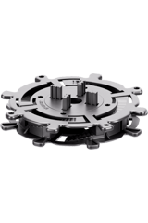 | 103.020311 | SPI-017-030-D5-(90) | Adjustable pedestal SPIRAL 17-30 mm for outdoor raised flooring for tiles with D5 / 90 pcs
Spiral | 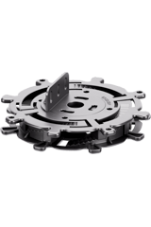 | 103.020411 | SPI-017-030-DAD-(90) | Adjustable pedestal SPIRAL 17-30 mm for outdoor raised flooring for decking with DAD / 90 pcs
Spiral | 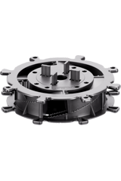 | 103.030211 | SPI-030-050-D3-(100) | Adjustable pedestal SPIRAL 30-50 mm for outdoor raised flooring for tiles with D3 / 100 pcs
Spiral | 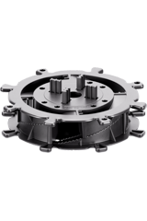 | 103.030311 | SPI-030-050-D5-(100) | Adjustable pedestal SPIRAL 30-50 mm for outdoor raised flooring for tiles with D5 / 100 pcs
Spiral | 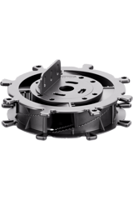 | 103.030411 | SPI-030-050-DAD-(100) | Adjustable pedestal SPIRAL 30-50 mm for outdoor raised flooring for decking with DAD / 100 pcs
Spiral | 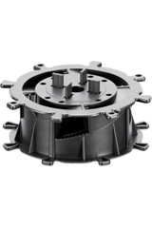 | 103.040211 | SPI-050-070-D3-(70) | Adjustable pedestal SPIRAL 50-70 mm for outdoor raised flooring for tiles with D3 / 70 pcs
Spiral | 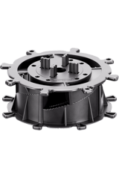 | 103.040311 | SPI-050-070-D5-(70) | Adjustable pedestal SPIRAL 50-70 mm for outdoor raised flooring for tiles with D5 / 70 pcs
Spiral | 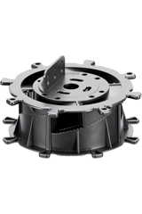 | 103.040411 | SPI-050-070-DAD-(70) | Adjustable pedestal SPIRAL 50-70 mm for outdoor raised flooring for decking with DAD / 70 pcs
Spiral | 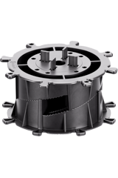 | 103.050211 | SPI-070-090-D3-(50) | Adjustable pedestal SPIRAL 70-90 mm for outdoor raised flooring for tiles with D3 / 50 pcs
Spiral | 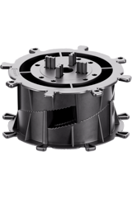 | 103.050311 | SPI-070-090-D5-(50) | Adjustable pedestal SPIRAL 70-90 mm for outdoor raised flooring for tiles with D5 / 50 pcs
Spiral | 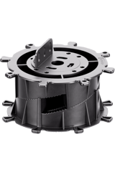 | 103.050411 | SPI-070-090-DAD-(50) | Adjustable pedestal SPIRAL 70-90 mm for outdoor raised flooring for decking with DAD / 50 pcs
Spiral | 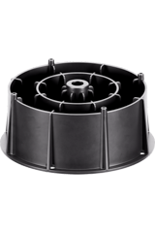 | 103.060111 | SPI-DS60-(70) | Height extender for SPIRAL - height 60 mm / 70 pcs
Max | 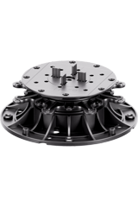 | 104.010211 | MAX-045-075-D3-(54) | Adjustable pedestal MAX 45-75 mm for outdoor raised flooring for tiles with D3 / 54 pcs
Max | 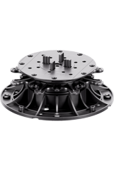 | 104.010311 | MAX-045-075-D5-(54) | Adjustable pedestal MAX 45-75 mm for outdoor raised flooring for tiles with D5 / 54 pcs
Max | 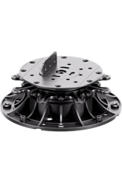 | 104.010411 | MAX-045-075-DAD-(54) | Adjustable pedestal MAX 45-75 mm for outdoor raised flooring for decking with DAD / 54 pcs
Max | 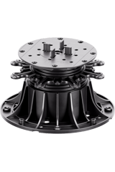 | 104.020211 | MAX-075-150-D3-(36) | Adjustable pedestal MAX 75-150 mm for outdoor raised flooring for tiles with D3 / 36 pcs
Max | 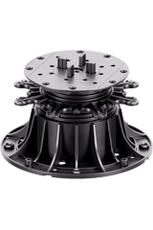 | 104.020311 | MAX-075-150-D5-(36) | Adjustable pedestal MAX 75-150 mm for outdoor raised flooring for tiles with D5 / 36 pcs
Max | 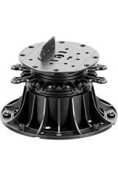 | 104.020411 | MAX-075-150-DAD-(36) | Adjustable pedestal MAX 75-150 mm for outdoor raised flooring for decking with DAD / 36 pcs
Max | 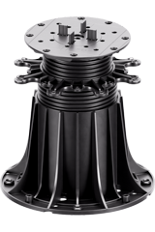 | 104.030211 | MAX-150-350-D3-(18) | Adjustable pedestal MAX 150-350 mm for outdoor raised flooring / 18 pcs
Max | 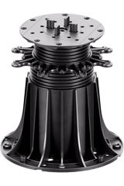 | 104.030311 | MAX-150-350-D5-(18) | Adjustable pedestal MAX 150-350 mm for outdoor raised flooring for tiles with D5 / 18 pcs
Max | 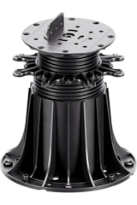 | 104.030411 | MAX-150-350-DAD-(18) | Adjustable pedestal MAX 150-350 mm for outdoor raised flooring for decking with DAD / 18 pcs
Max | 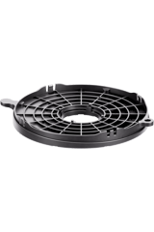 | 104.040111 | MAX-SC-(72) | Base slope corrector for MAX with maximum slope compensation 8% / 72 pcs
Max | 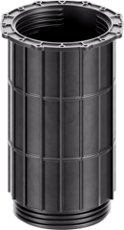 | 104.050111 | MAX-DS200-(30) | Height coupler for MAX - height 200 mm / 30 pcs
Raptor | 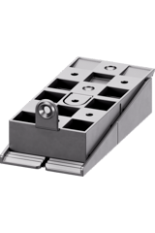 | 106.010111 | RAP-S-15-35-(100) | Wedge decking pedestal RAPTOR 15-35 mm for outdoor raised flooring / 100 pcs
Raptor | 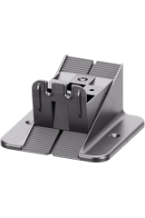 | 106.030111 | RAP-M-35-65-(100) | Wedge decking pedestal RAPTOR M 35-65 mm for outdoor raised flooring / 100 pcs
Raptor | 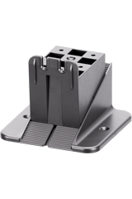 | 106.050111 | RAP-L-65-95-(100) | Wedge decking pedestal RAPTOR L 65-95 mm for outdoor raised flooring / 100 pcs
Raptor | 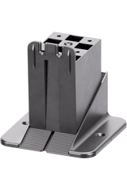 | 106.070111 | RAP-XL-95-125-(55) | Wedge decking pedestal RAPTOR XL 95-125 mm for outdoor raised flooring / 55 pcs
Raptor | 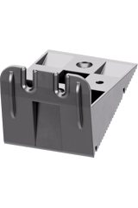 | 106.020111 | RAP-KM-(100) | Top wedge M for RAPTOR pedestal / 100 pcs
Raptor | 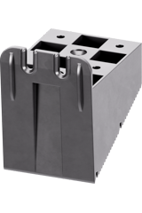 | 106.040111 | RAP-KL-(100) | Top wedge L for RAPTOR pedestal / 100 pcs
Raptor | 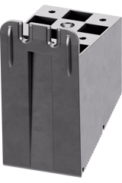 | 106.060111 | RAP-KXL-(100) | Top wedge XL for RAPTOR pedestal / 100 pcs
Raptor | 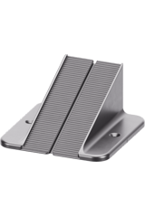 | 106.080111 | RAP-PL-(100) | Bottom wedge L for RAPTOR pedestal / 100 pcs
Raptor | 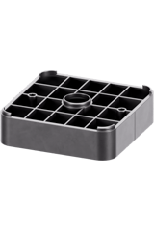 | 106.090111 | RAP-P30-(100) | Height extender for RAPTOR - height 30 mm / 100 pcs
Raptor | 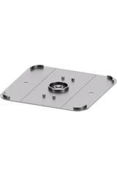 | 106.100111 | RAP-PO-(100) | Protection pad for RAPTOR pedestal - height 2 mm / 100 pcs
Raptor | 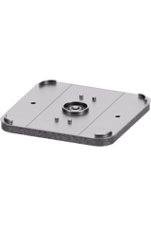 | 106.110111 | RAP-PA-(50) | Acoustic pad for RAPTOR pedestal - height 10 mm / 50 pcs
Raptor | 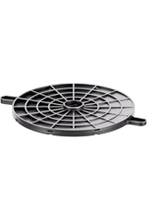 | 106.120111 | RAP-KN-(50) | Base slope corrector for RAPTOR with maximum slope compensation 7% / 50 pc
Alu | 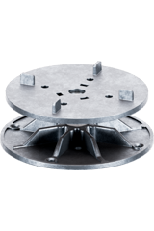 | 107.010111 | ALU-040-050-L3-(40) | Adjustable pedestal ALU 40-50 mm for outdoor raised flooring with tiles - non combustible class A1 / 40 pcs
Alu | 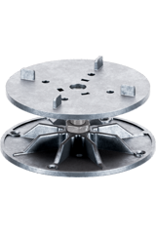 | 107.020111 | ALU-050-060-L3-(40) | Adjustable pedestal ALU 50-60 mm for outdoor raised flooring with tiles - non combustible class A1 / 40 pcs
Alu | 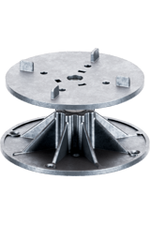 | 107.030111 | ALU-060-075-L3-(40) | Adjustable pedestal ALU 60-75 mm for outdoor raised flooring with tiles - non combustible class A1 / 40 pcs
Alu | 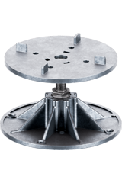 | 107.040111 | ALU-070-095-L3-(40) | Adjustable pedestal ALU 70-95 mm for outdoor raised flooring with tiles - non combustible class A1 / 40 pcs
Alu | 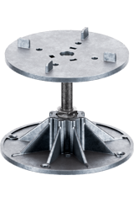 | 107.050111 | ALU-090-115-L3-(40) | Adjustable pedestal ALU 90-115 mm for outdoor raised flooring with tiles - non combustible class A1 / 40 pcs
Alu | 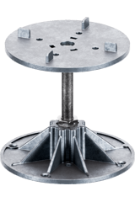 | 107.060111 | ALU-110-135-L3-(40) | Adjustable pedestal ALU 110-135 mm for outdoor raised flooring with tiles - non combustible class A1 / 40 pcs
Alu | 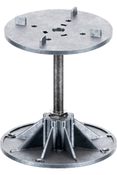 | 107.070111 | ALU-130-155-L3-(40) | Adjustable pedestal ALU 130-155 mm for outdoor raised flooring with tiles - non combustible class A1 / 40 pcs
Alu | 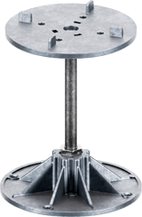 | 107.080111 | ALU-150-175-L3-(40) | Adjustable pedestal ALU 150-175 mm for outdoor raised flooring with tiles - non combustible class A1 / 40 pcs
Alu | 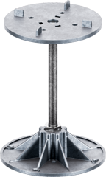 | 107.090111 | ALU-170-200-L3-(40) | Adjustable pedestal ALU 170-200 mm for outdoor raised flooring with tiles - non combustible class A1 / 40 pcs
Accessories | 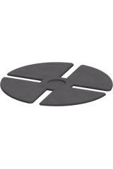 | 110.011031 | AKCW-SH100-(100) | Sound and vibration dampening rubber shim for STANDARD and CLEVER LEVEL - diameter 100 mm, thickness 1,5 mm / 100 pcs
Accessories | 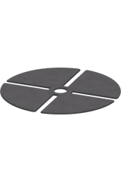 | 110.013021 | AKCW-SH145-(50) | Sound and vibration dampening rubber shim for SPIRAL and MAX - diameter 145 mm, thickness 1,5 mm / 50 pcs
Accessories | 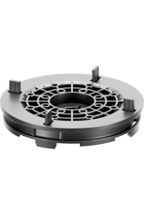 | 110.051011 | AKCW-LE145-(100) | Self leveling head for SPIRAL,MAX with maximum slope compensation 6% - height 20 mm / 100 pcs
Accessories | 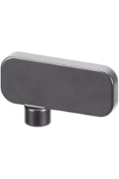 | 110.021051 | AKCW-L3-(25) | Individual gap spacer for tiles 3 mm / 25 pcs
Accessories | 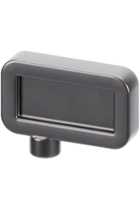 | 110.022021 | AKCW-L5-(25) | Individual gap spacer for tiles 5 mm / 25 pcs
Accessories | 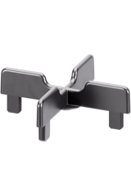 | 110.023051 | AKCW-K3-(25) | Cross gap spacer for tiles 3 mm / 25 pcs
Accessories | 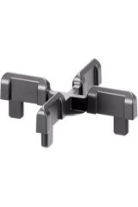 | 110.024021 | AKCW-K5-(25) | Cross gap spacer for tiles 5 mm / 25 pcs
Accessories | 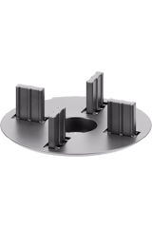 | 110.025051 | AKCW-D3-(25) | Disc gap spacer for tiles 3 mm / 25 pcs
Accessories | 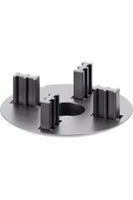 | 110.026041 | AKCW-D5-(25) | Disc gap spacer for tiles 5 mm / 25 pcs
Accessories | 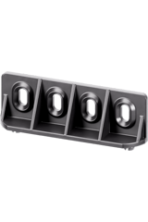 | 110.031051 | AKCW-AD-(25) | Joist adapter for STANDARD - height 28 mm / 25 pcs
Accessories | 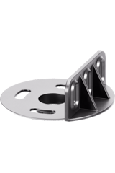 | 110.032051 | AKCW-DAD-(25) | Joist adapter for SPIRAL, MAX - height 26 mm / 25 pcs
Accessories | 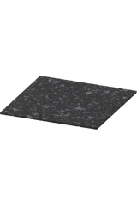 | 110.041011 | AKCW-SBR200X200X3-(60) | Rubber bottom protection pad SBR 200x200x3 mm / 60 pcs
Accessories | 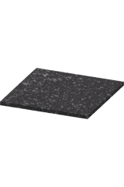 | 110.042011 | AKCW-SBR200X200X8-(20) | Rubber bottom protection pad SBR 200x200x8 mm / 20 pcs
Accessories | 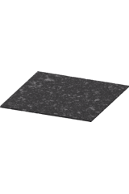 | 110.043011 | AKCW-SBR220X220X3-(60) | Rubber bottom protection pad SBR 220x220x3 mm / 60 pcs
Accessories | 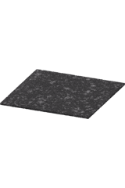 | 110.044011 | AKCW-SBR170X170X3-(100) | Rubber bottom protection pad SBR 170x170x3 mm / 100 pcs
Accessories | 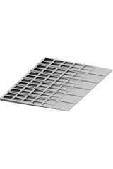 | 110.045021 | AKCW-KP3-(140) | Leveling wedge 3% / 140 pcs
Accessories | 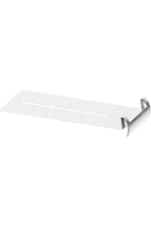 | 110.061011 | AKCW-WA-(200) | Perimeter spacer clip - inox / 200 pcs
Accessories | 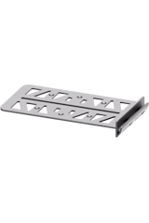 | 110.062011 | AKCW-WAP-(125) | Perimeter spacer clip - plastic / 125 pcs
Accessories | 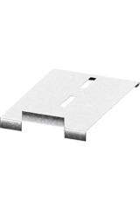 | 110.063021 | AKCW-EDU-STA-(100) | Vertical closure clip for STANDARD - upper, inox / 100 pcs
Accessories | 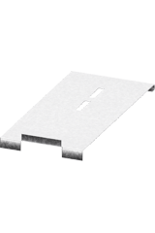 | 110.064011 | AKCW-EDU-MAX-(150) | Vertical closure clip for MAX - upper, inox / 150 pcs
Accessories | 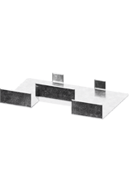 | 110.065021 | AKCW-EDL-STA-(150) | Vertical closure clip - inox, lower / 150 pcs
Accessories | 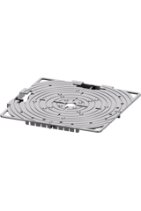 | 110.066031 | AKCW-CP-B-(20X2) | Vertical closure clips set for SPIRAL, STANDARD, MAX - black / 20 sets
Accessories | 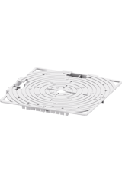 | 110.067021 | AKCW-CP-G-(20X2) | Vertical closure clips set for SPIRAL, STANDARD, MAX - grey / 20 sets
Accessories | 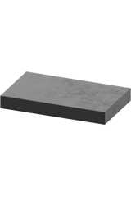 | 110.068011 | AKCW-KD-(5000) | Self adhesive tile edge rubber block for perimeter - thickness 3,5 mm
Accessories | 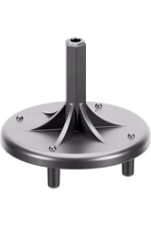 | 110.071011 | AKCW-PPK-(1) | Drill driver pedestal turning tool for STANDARD, MAX, CLEVER LEVEL / 1 pc
Accessories | 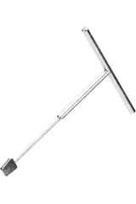 | 110.072011 | AKCW-MPK-(1) | Pedestal height adjustment top key for MAX / 1 pc
Accessories | 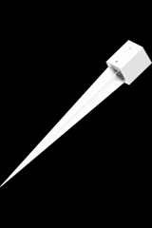 | 110.083011 | AKCW-MFW-(1) | Metal anchor foundation 160 mm (total length 1000 mm) / 1 pc
Accessories | 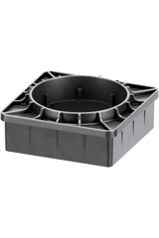 | 110.084011 | AKCW-RPL-(60) | Adjustable deck joist support for anchor foundation with height adjustment 100 mm / 60 pcs
Novabord | 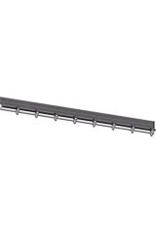 | 201.010111 | NOV-OT-(80) | Lawn edging NOVABORD - length 1000 mm, height 100 mm - black / 80 pcs
Novabord | 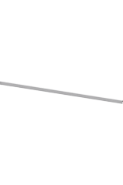 | 201.020111 | NOV-NOTO-(80) | Steel overlay top finish for NOVABORD - galvanized steel / 80 pcs
Novabord | 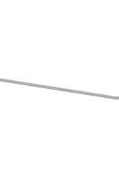 | 201.020211 | NOV-NOTI-(80) | Steel overlay top finish for NOVABORD - inox / 80 pcs
Novabord | 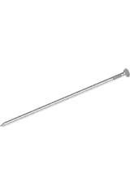 | 201.030111 | NOV-NAILMET-(30) | Steel anchor for NOVABORD - length 275 mm / 30 pcs
Novabord | 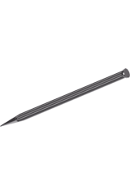 | 201.030211 | NOV-NAILPLA-(40) | Plastic anchor for NOVABORD - length 240 mm / 40 pcs
Deck-Dry | 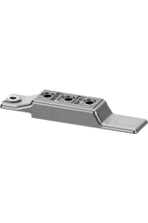 | 301.010111 | DEC-LT90-(400) | Hidden deck fastener DECK-DRY, plank width 83-90 mm / 400 pcs
Deck-Dry | 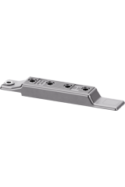 | 301.010211 | DEC-LT120-(300) | Hidden deck fastener DECK-DRY, plank width 112-121 mm / 300 pcs
Deck-Dry | 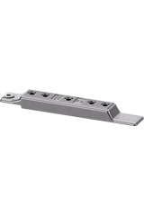 | 301.010311 | DEC-LT145-(250) | Hidden deck fastener DECK-DRY, plank width 138-145 mm / 250 pcs
Deck-Dry | 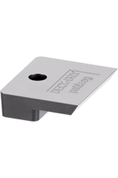 | 301.010411 | DEC-STEND-(1000) | Start-end clip for hidden deck fasteners DECK-DRY, screw included / 1000 pcs
Deck-Dry | 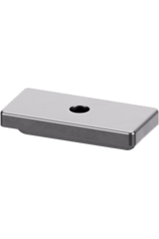 | 301.010511 | DEC-WPCK-(1000) | Hidden T clip for WPC decking / 1000 pcs
Deck-Dry | 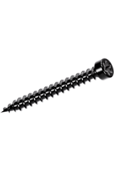 | 301.020111 | DEC-T5X30OC-(2000) | Hidden deck fastener DECK-DRY screw for joists (wood, WPC, aluminium) 5X30 - galvanized black / 2000 pcs
Deck-Dry | 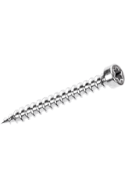 | 301.020211 | DEC-T5X30NS-(2000) | Hidden deck fastener DECK-DRY screw for joists (wood, WPC, aluminium) 5X30 - silver inox / 2000 pcs
Deck-Dry | 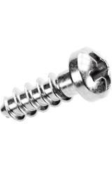 | 301.020311 | DEC-W6X18O-(2000) | Hidden deck fastener DECK-DRY screw UW6.0X18 (plank thickness min 21 mm) - galvanized silver / 2000 pcs
Deck-Dry | 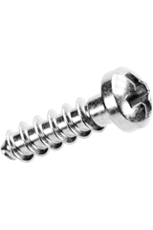 | 301.020411 | DEC-W6X21O-(2000) | Hidden deck fastener DECK-DRY screw UW6.0X21 (plank thickness min 25 mm) - galvanized silver / 2000 pcs
Deck-Dry | 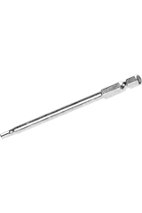 | 301.030111 | DEC-BIT20-(1) | Screwdriver Bit T20 extended length for hidden deck fastener DECK-DRY / 1 pc
Accessories | 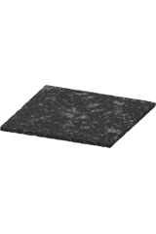 | 301.040111 | AKCT-SBR100X100X3-(300) | Rubber joist pad SBR 100x100x3 mm / 300 pcs
Accessories | 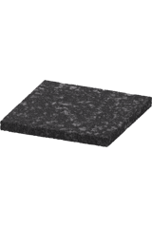 | 301.040211 | AKCT-SBR100X100X8-(100) | Rubber joist pad SBR 100x100x8 mm / 100 pcs
Accessories | 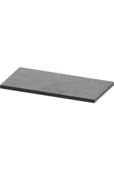 | 301.040311 | AKCT-FIX80X40X3-(2000) | Multi puprose rubber pad 80x40x3 mm / 2000 pcs
Accessories | 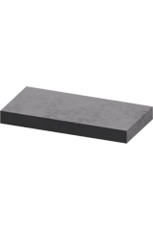 | 301.040411 | DEC-FIX80X40X8-(840) | Multi puprose rubber pad 80x40x8 mm / 800 pcs
Accessories | 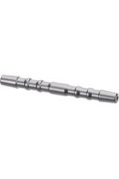 | 301.050121 | AKCT-PIN6-(960) | SBR Interlocking pin - diameter 6 mm / 960 pcs
Accessories | 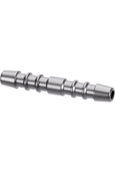 | 301.050221 | AKCT-PIN10-(800) | SBR Interlocking pin - diameter 10 mm / 800 pcs
Accessories | 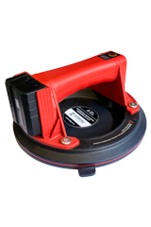 | 301.060111 | AKCT-APP-(1) | Electric Vacuum Suction Cup Lifter - max. weight 200kg, diameter 20 cm (8 inch), 2400mAh Li-ion Detachable Battery / 1 pc

